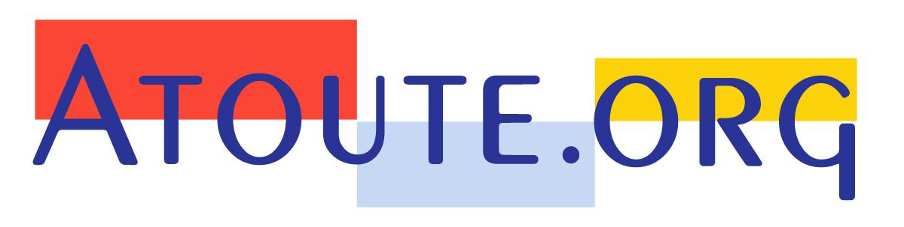

“Is Independence in the field of health an utopian concept ?”

Yes. Absolute independence does not exist. This reality is often presented as an excuse by those who want to justify their multiple dependences.

What is not utopian is to find how to limit to the maximum the alienation of our reason and judgment skills by parasitic influences. Independence becomes a global objective, a value that we cherish. I prefer the fight against dependencies rather than the impossible independence.

“Through your own experience and your role have you observed a change in behaviours in relation to this concept over the last 10 years?”
Of course, the successive scandals have shown to the public how the independence of experts and institutions were a myth, and that science is not structurally protected against fraud, manipulation and corruption.

The A/H1N1 flu, even more than the Mediator scandal, was important for raising awareness among the public. There is a serious loss of confidence among citizens that will take a long time to heal. Without reliable scientific references, the patient is discouraged, confused and relies on doctors that he trusts for his health care; unfortunately, I am afraid that recent evolutions such as pay-for-performances schemes may undermine this last trusting relationship by introducing a new dependence.

Among health professionals, there are 2 quite distinct groups. To simplify, readers of the Prescrire journal are aware of the risk of dependence and look for the most independent information. Others live in an unreal world where sale representatives would bring objective information to prescribers and where in-kind gifts of the pharmaceutical industry would not influence them.

Personally, I believe in Medicine 2.0, in the force of sharing and of the community.
I believe there should be an end to centralised expertise because is too easy to corrupt. I believe in the joined strength of honest doctors and patients. This opinion is often disputed, but the FORMINDEP and the active Réunion doctors, would they get such an audience and current fame without internet ? The collective paper we wrote on the flu vaccination in 2009, would have it had over a million readers?

The specialized journalists know it and question us now on all sensitive issues. This is a new phenomenon that appeared since 2010, when they understood that the flu experts and health authorities had taken them for a ride.

What do you think of the organization of such a seminar on medical independence? '
Two aspects are interesting.

Firstly, the initiative by itself. Talking of independence gives the opportunity of convincing other colleagues of the dangers of dependence. It will also show to the public that there are doctors who are concerned about these questions and think first and foremost of protecting the health of their patients.

The other encouraging element is the success of this conference and the presence of institutional representatives. This struggle against dependence has come out of the ghetto and health authorities are more and more involved. Most certainly the road will be long and the concealment of conflicts of interest is unfortunately also increasing, but this collective awareness is stimulating.

Dominique Dupagne
November 2012
http://www.atoute.org/

